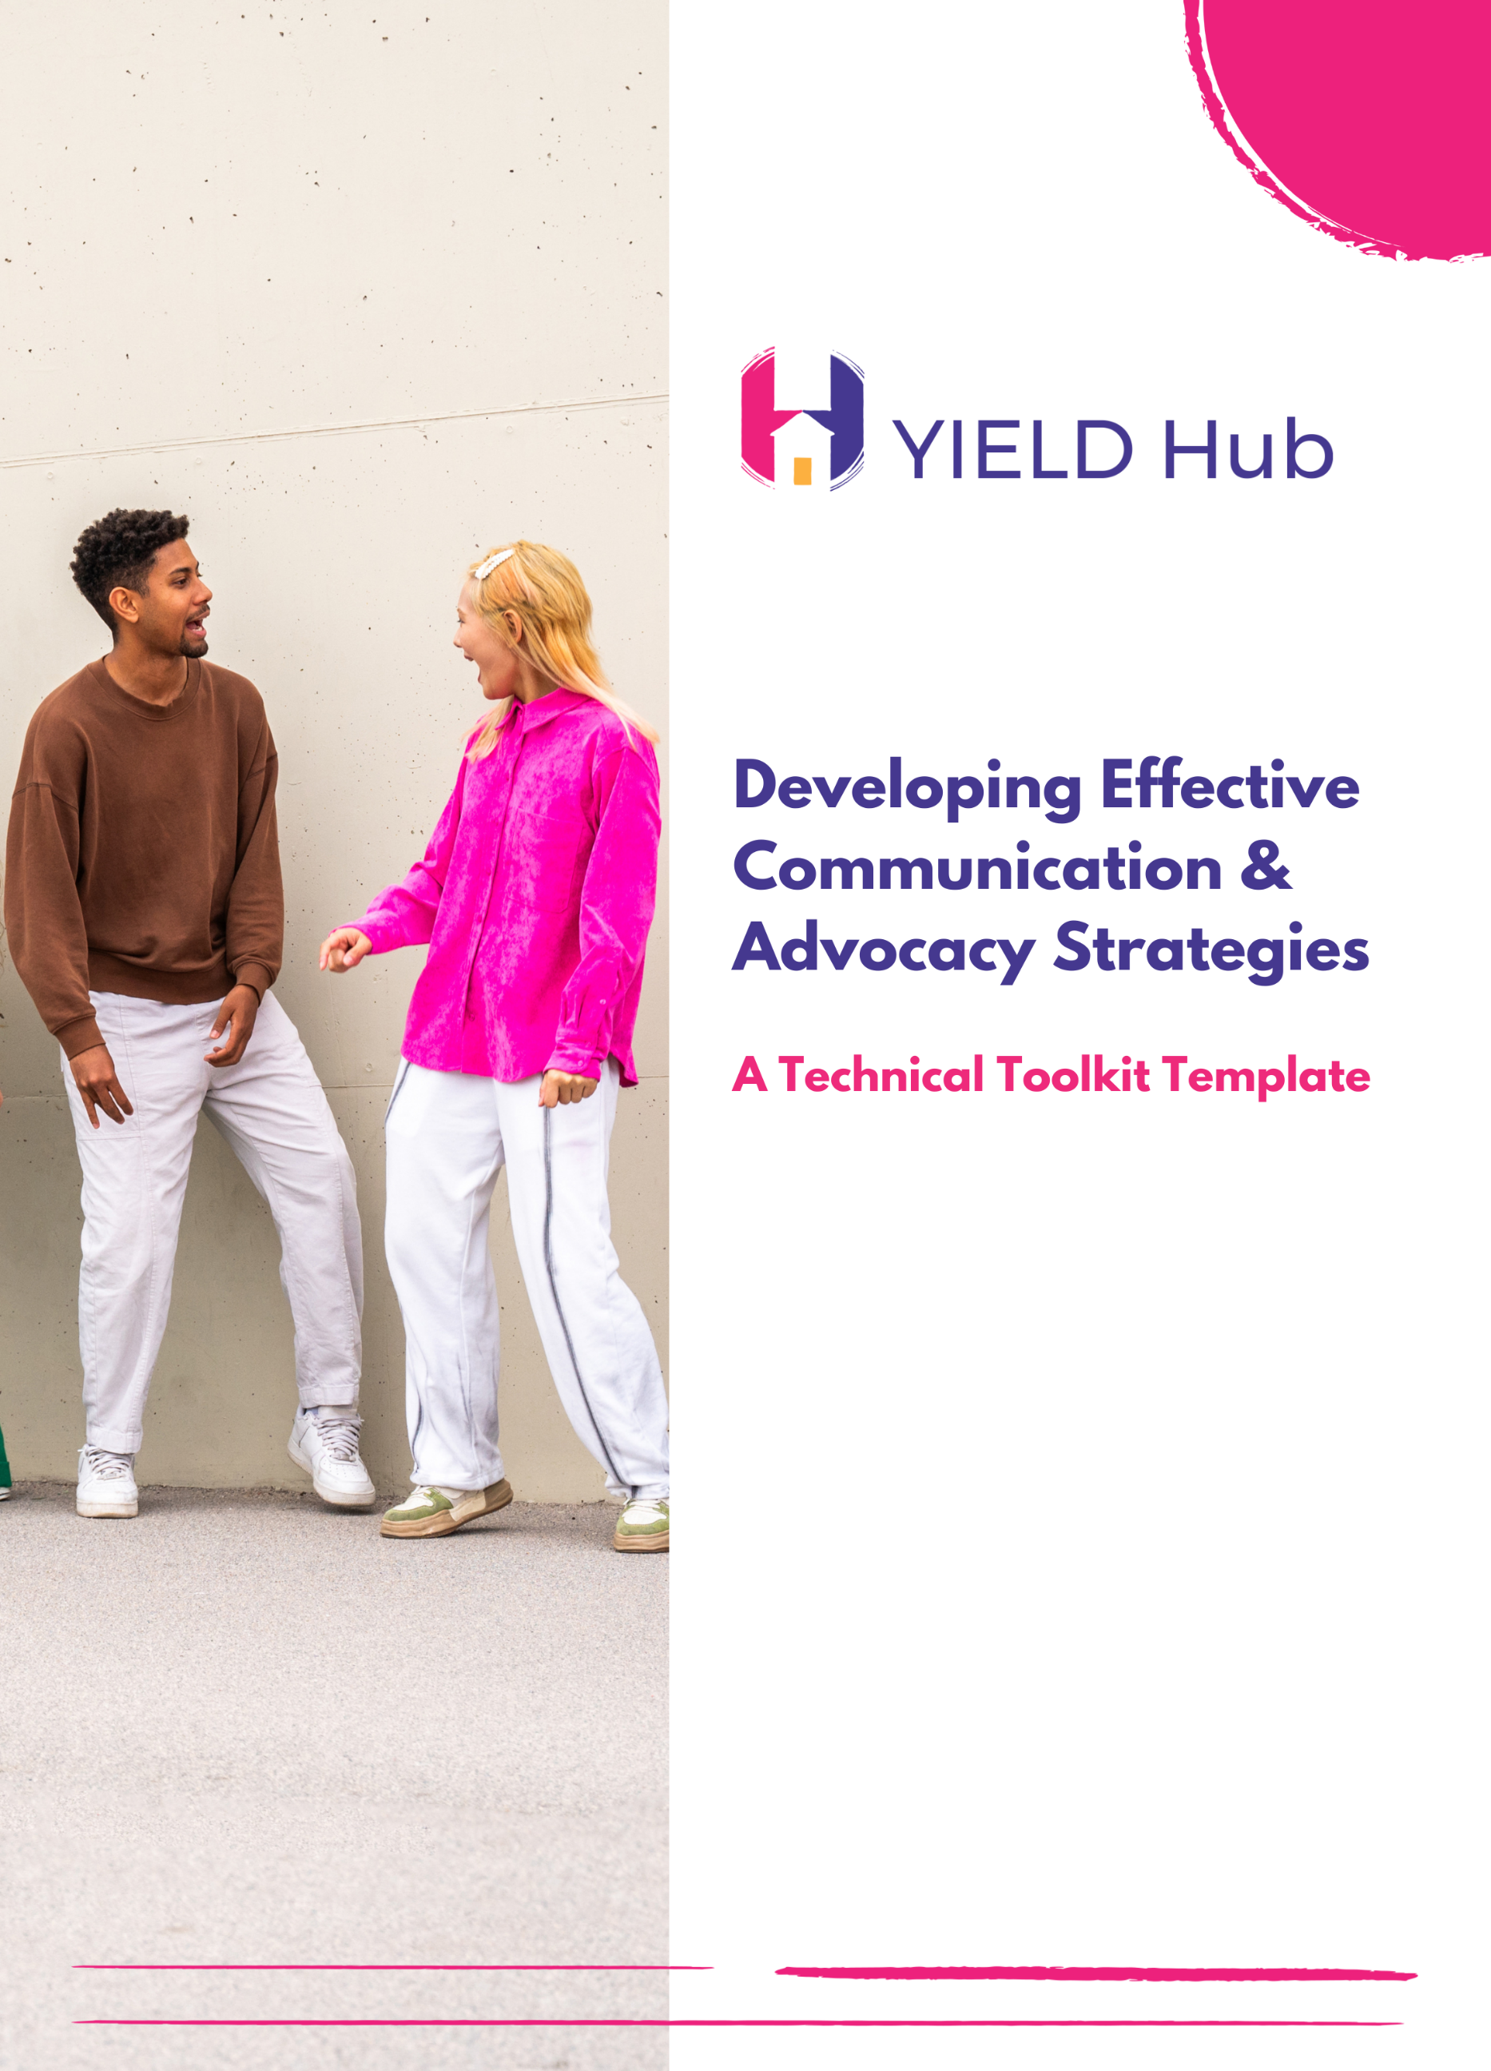

**This toolkit is designed to serve as a comprehensive guide for developing and improving advocacy and communication. Its core aim is to equip you with the necessary tools and frameworks to effectively craft, plan, and evaluate communication strategies that resonate and create impact. Whether you're working in advocacy, nonprofit communication, or any sector where messaging is key, this toolkit aims to enhance your approach.**

**Target Audience Analysis**

Knowing your audience is a fundamental aspect of any successful advocacy campaign. This section is designed to guide you in identifying and understanding the specific group or groups most relevant to your advocacy efforts. By systematically analysing your audience, you will be able to tailor your strategies and messages more effectively, ensuring they resonate with the right people.

**Part 1: Basic Information**

1. **Target Group Name:** *(Provide a brief name for the target audience group)*

|  |
| --- |
|  |

1. **Key Characteristics:** *(Age range, gender, location, etc.)*

|  |
| --- |
|  |

1. **Relevance to Advocacy Topic:** *(Why is this group important for your advocacy efforts?)*

|  |
| --- |
|  |

**Part 2: Understanding the Audience**

1. **Interests and Concerns:**

What are the primary interests of this group?

|  |
| --- |
|  |

What concerns might they have related to the advocacy topic?

|  |
| --- |
|  |

1. **Communication Preferences:**

Preferred Media Channels: *(Which media do they use most? e.g., local newspapers, radio, social media)*

|  |
| --- |
|  |

Content Types: *(What type of content do they engage with? e.g., articles, videos, images)*

|  |
| --- |
|  |

1. **Influencers and Community Leaders:**

Who influences this group? *(Community leaders, local celebrities, etc.)*

|  |
| --- |
|  |

How can these influencers be engaged in the advocacy effort?

|  |
| --- |
|  |

**Part 3: Empathy and Engagement**

1. **Empathy Exercise:**

Imagine a day in the life of someone from this group. What challenges do they face? What are their aspirations?

|  |
| --- |
|  |

1. **Engagement Ideas:**

List some ideas on how you could engage with this group effectively. *(Workshops, community meetings, social media campaigns, etc.)*

|  |
| --- |
|  |

**Part 4: Feedback and Observations**

1. **Feedback Collection Methods:**

How will you collect feedback from this group? *(Surveys, informal interviews, community feedback sessions)*

|  |
| --- |
|  |

1. **Observations:**

Note any observations or insights gained while conducting this exercise.

|  |
| --- |
|  |

**Message Crafting Exercise**

Crafting the right message is critical in advocacy. It's not just about what you say, but how you say it. This template is a practical tool to help you formulate clear, compelling, and persuasive messages for your advocacy work. It guides you through the essential components of effective messaging, from establishing a core message to considering the best formats for audience engagement. Examples of how to respond to each question have been provided in brackets as a guide.

**Part 1: Message Foundation**

1. **Core Message:**

What is the primary point or call to action you want to communicate? You may refer to your organisational strategy as a reminder of your vision and mission, goals and objectives. (*"Support comprehensive sexual education to empower youth with knowledge and rights.")*

|  |
| --- |
|  |

1. **Target Audience:**

Who is the intended audience for this message? (*Parents and educators in urban communities.)*

|  |
| --- |
|  |

What are their key characteristics and preferences? (*Key characteristics: mid-30s to 50s, value education, active on social media.)*

|  |
| --- |
|  |

**Part 2: Crafting the Message**

1. **Storytelling Element:**

Outline a brief story or scenario that supports your core message. (*"Sarah, a 16-year-old student, felt empowered and safe making informed decisions about her health after attending a comprehensive sexual education program.")*

|  |
| --- |
|  |

1. **Benefits Over Features:**

List the benefits of your advocacy effort for the audience. (*Enhanced safety and well-being for youth.* *Informed youth making responsible choices.)*

|  |
| --- |
|  |

1. **Call to Action:**

What specific action do you want the audience to take? (*"Join our campaign to bring comprehensive sexual education to our schools. Your support can make a difference!")*

|  |
| --- |
|  |

**Part 3: Engagement Strategies**

1. **Visual Elements:**

What visuals will you use to support your message? E.g., images, infographics, videos. (*Infographics showing the benefits of sexual education.)*

|  |
| --- |
|  |

1. **Interactive Content:**

Propose an interactive element E.g., poll, quiz, questionnaire. (*Online quiz about myths and facts of sexual education.)*

|  |
| --- |
|  |

**Part 4: Communication Channels**

1. **Primary Communication Channel(s):**

Which media channels will you use to deliver this message? Consider your audience’s preferences. (*Facebook and Instagram, considering the audience's active social media use.)*

|  |
| --- |
|  |

1. **Adaptation Across Channels:**

How will you adapt this message for different channels? (*Short video clips for Instagram stories; detailed posts and articles for Facebook.)*

|  |
| --- |
|  |

**Part 5: Feedback and Refinement**

1. **Feedback Mechanism:**

How will you collect feedback on your message? (*Online survey shared via social media and email newsletters.)*

|  |
| --- |
|  |

1. **Refinement Ideas:**

Note down any ideas for refining the message based on potential feedback. (*Adjust messaging based on survey feedback, particularly focusing on addressing common concerns or misconceptions.)*

|  |
| --- |
|  |

**Advocacy Plan Development Template**

An effective advocacy plan is the backbone of any successful campaign. This section serves as a roadmap for creating a structured and strategic approach to your advocacy efforts. It covers all key stages of planning, from defining the issue to setting goals and monitoring progress.

1. **Identify the Issue:**

* *What is the specific issue you are addressing?*
* **Example:** *"Increasing access to reproductive health services for teenagers in urban areas."*

|  |
| --- |
|  |

2. **Set Goals and Objectives:**

* *What are your overall goals and specific objectives?*
* **Example Goal:** *"To improve reproductive health among teenagers."*
* **Example Objective:** *"To increase the use of reproductive health services by teenagers by 30% within one year."*

|  |
| --- |
|  |

3. **Audience and Stakeholder Analysis:**

* *Who is your primary audience and who are the key stakeholders?*
* **Example Audience:** *"Teenagers, parents, healthcare providers."*
* **Example Stakeholders:** *"Local schools, community organizations, health clinics."*

|  |
| --- |
|  |

4. **Develop Your Message:**

* *What are your key messages? How will they resonate with your audience?*
* **Example Message:** *"Accessible reproductive health services lead to healthier and more informed teenagers."*

|  |
| --- |
|  |

5. **Plan Tactics and Activities:**

* *What tactics and activities will you use to achieve your objectives?*
* **Example Tactics:** *"Awareness campaigns, partnerships with schools, community workshops."*

|  |
| --- |
|  |

6. **Allocate Resources:**

* *What resources (time, money, personnel) are needed?*
* **Example:** *"Estimated budget of $20,000, 2 full-time staff, volunteer support."*

|  |
| --- |
|  |

7. **Implementation Timeline:**

* *What is the timeline for your activities? Include key milestones.*
* **Example:** *"Launch campaign in June, partner with schools by September, evaluate progress bi-monthly."*

|  |
| --- |
|  |

8. **Monitoring and Evaluation:**

* *How will you measure the success of your advocacy efforts?*
* **Example Metrics:** *"Number of teenagers using health services, survey feedback from participants, number of schools participating."*

|  |
| --- |
|  |

9. **Adapt and Evolve:**

* *How will you adapt your plan based on feedback or changing circumstances?*
* **Example:** *"Regular team meetings to discuss progress and challenges, adjust tactics if certain activities are not yielding expected results."*

|  |
| --- |
|  |

**Communications and Advocacy Strategy Success Checklist**

Regular assessment of your strategy is vital for continual improvement and success. This checklist is intended to help you evaluate and strengthen your organisation's communications and advocacy strategy. It provides a comprehensive list of key factors that contribute to the success of advocacy efforts. You can print these last two pages if it will make it easier for you to complete the checklist with your team.

**Date:** ___________________

**1. Goals and Objectives**

* Our goals and objectives are clearly defined and SMART (Specific, Measurable, Achievable, Relevant, Time-bound).
* We have a clear understanding of what we aim to achieve with our advocacy efforts.

**2. Audience Analysis**

* We have identified and understand our target audience(s).
* Our strategies are tailored to meet the needs and preferences of our audience(s).

**3. Clear Messaging**

* Our messaging is clear, concise, and persuasive.
* We ensure our messages are relevant and resonate with our target audience.

**4. Strong Storytelling**

* We use storytelling to make emotional connections and illustrate our message.
* Real-life stories and examples are integrated into our communications.

**5. Media Channel Strategy**

* We have selected appropriate media channels based on our audience's habits.
* Our media strategy covers a mix of digital, traditional, and social media platforms.

**6. Consistency Across Platforms**

* Our messaging is consistent across all communication platforms.
* We maintain a cohesive brand and campaign identity.

**7. Engagement and Interaction**

* We actively encourage audience participation and feedback.
* Opportunities for dialogue and community building are integrated into our strategy.

**8. Partnerships and Networks**

* We collaborate with other organizations, influencers, and stakeholders.
* Partnerships are utilized to extend reach and credibility.

**9. Monitoring and Evaluation**

* We regularly monitor and evaluate the impact of our communications.
* Our strategy is adaptable, based on feedback and results.

**10. Transparency and Honesty**

* Our communication is transparent regarding our goals and challenges.
* Honesty is a core value in our messaging.

**11. Sensitivity and Inclusiveness**

* We are sensitive to cultural, social, and political contexts.
* Our communications are inclusive and respectful to all groups.

**12. Crisis Management**

* We have a crisis management plan for our communications.
* Our team is prepared to respond quickly and thoughtfully in crises.

**Moving Forward**

As you implement these tools in your work:

* Stay adaptable to changes and open to learning.
* Keep your audience's needs and feedback at the forefront.
* Regularly review and update your strategies to ensure they remain relevant and impactful.

Your commitment to developing effective communication strategies is commendable, and we are confident that the use of this toolkit will lead to meaningful engagements and successful advocacy outcomes. If you’ve struggled completing any sections of this toolkit, we invite you to reach out to us via email, [info@yieldhub.global](mailto:info@yieldhub.global) for any support you require.